Teacher(s): Mrs. Breazeale, Ms. Streeter, & Mrs. Whittemore Subject/Grade: 7th /Grade Math Week of: May 29, 2023
Domain: See Below/Cross Curriculum with Science Lesson Plan Title: The Green Island

 | Mississippi College and Career Readiness Standards for 7th Grade Mathematics
The Number System | 7.NS. 1 Apply and extend previous understandings of addition and subtraction to add and subtract rational numbers; represent addition and subtraction on a horizontal or vertical number line diagram.  7.NS.2 Apply and extend previous understandings of multiplication and division and of fractions to multiply and divide rational numbers.  7.NS.3 Solve real-world and mathematical problems involving the four operations with rational numbers.
Ratios & Proportions | 7.RP.2 Recognize and represent proportional relationships between quantities.
Expressions & Equations | 7.EE.4 Use variables to represent quantities in a real-world or mathematical problem, and construct simple equations and inequalities to solve problems by reasoning about the quantities.
ESSENTIAL QUESTION: How would creating a green island benefit life on Earth?
Science
Earth’s Systems & Cycles
Conceptual Understanding: Complex patterns in the movement of air and water in the atmosphere are major determinants of local weather. Global movements of water and its changes in form are propelled by sunlight and gravity. Variations in temperature drive a global pattern of interconnected currents. Interactions between sunlight, oceans, atmosphere, ice, landforms, and living things vary with latitude, altitude, and local and regional geography. Weather is difficult to predict; however, large-scale patterns and trends in global climate, such as the gradual increase in average temperature, are more easily observed and predicted.
E.7.9A Students will demonstrate an understanding of how complex changes in the movement and patterns of air and water molecules caused by the sun, winds, landforms, ocean temperatures, and currents in the atmosphere are major determinants of local and global weather patterns.
E.7.9A.1 Analyze and interpret weather patterns from various regions to differentiate between weather and climate.
E.7.9A.2 Analyze evidence to explain the weather conditions that result from the relationship between the movement of water and air masses.
E.7.9A.3 Interpret atmospheric data from satellites, radar, and weather maps to predict weather patterns and conditions.
E.7.9A.4 Construct an explanation for how climate is determined in an area using global and surface features (e.g. latitude, elevation, shape of the land, distance from water, global winds and ocean currents).
E.7.9A.5 Analyze models to explain the cause and effect relationship between solar energy and convection and the resulting weather patterns and climate conditions.
E.7.9A.6 Research and use models to explain what type of weather (thunderstorms, hurricanes, and tornadoes) results from the movement and interactions of air masses, high and low pressure systems, and frontal boundaries.
E.7.9A.7 Interpret topographic maps to predict how local and regional geography affect weather patterns and make them difficult to predict.

Speaking & Listening
CCR.SL.1: Prepare for and participate effectively in a range of conversations and collaborations with diverse partners, building on others’ ideas and expressing their own clearly and persuasively.
SL.7.1a Come to discussions prepared, having read or researched material under study; explicitly draw on that preparation by referring to evidence on the topic, text, or issue to probe and reflect on ideas under SL.7.1b Follow rules for collegial discussions, track progress toward specific goals and deadlines, and define individual roles as needed.scussion.
SL.7.5 Include multimedia components and visual displays in presentations to clarify claims and findings and emphasize salient points.
SL.7.6 Adapt speech to a variety of contexts and tasks, demonstrating command of formal English when indicated or appropriate.

Language
CCR.L.1: Demonstrate command of the conventions of standard English grammar and usage when writing (printing, cursive, or keyboarding) or speaking.
CCR.L.2: Demonstrate command of the conventions of standard English capitalization, punctuation, and spelling when writing.
L.7.2b Spell correctly.
CCR.L.4: Determine or clarify the meaning of unknown or multiple-meaning words and phrases by using context clues, analyzing meaningful word parts, and consulting general and specialized reference materials, as appropriate.
CCR.L.6: Acquire and use accurately a range of general academic and domain-specific words and phrases sufficient for reading, writing, speaking, and listening at the college and career readiness level; demonstrate independence in gathering vocabulary knowledge when considering a word or phrase important to comprehension or expression.
L.7.6 Acquire and use accurately grade-appropriate general academic and domain specific words and phrases; gather vocabulary knowledge when considering a word or phrase important to comprehension or expression.

May 29, 2023- Monday
Memorial Day (No school)

With Science
May 30, 2023- Tuesday & May 31, 2023- Wednesday
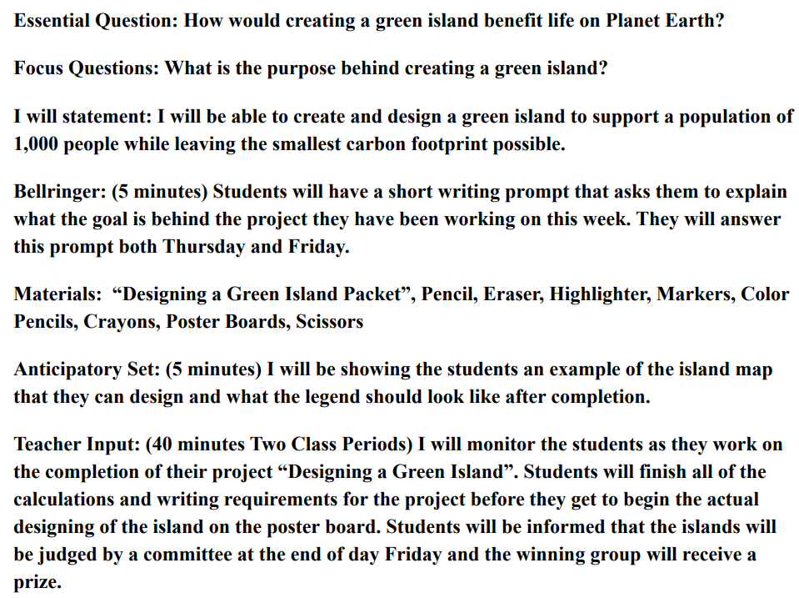

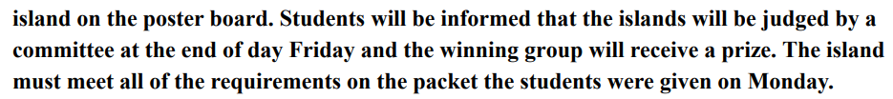
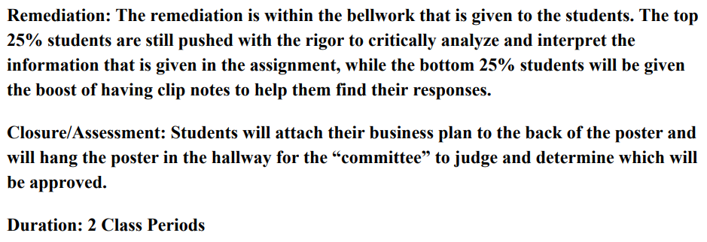

Thursday: Jun 1, 2023
Bell Ringer: TSW get notebook paper, pencil, calculator, and login to iReady.
Independent Practice: (~50 minutes)
The student will…
- Complete an iReady lesson on their path. (Most students are placed on the 7th grade level.)
- Take notes of important vocabulary and at least 3 examples.
- Listen to the lesson out loud so the teacher knows they are listening.
- Pass at least one lesson and obtain 45 minutes.
Teacher Interventions:
The teacher will…
- NOT help students with the lesson.
- Only help students on their quiz if they have copied the necessary vocabulary and 3 examples from the lesson.
Assessment: Completed iReady Lesson(s)
Friday: Jun 2, 2023
Bell Ringer: TSW get notebook paper, pencil, calculator, and login to iReady.
Independent Practice: (~50 minutes)
The student will…
- Login to Math Prodigy and complete a variety of 7th grade math skills.
- Take notes from the blue light bulbs when help is needed.
- Complete 30 questions.
Teacher Interventions:
The teacher will…
- NOT help students unless they have attempted to work out the problem on paper first/.
Assessment: Completed 30 questions
Monday: Jun 5, 2023
Bell Ringer: TSW get notebook paper, pencil, calculator, and login to iReady.
Independent Practice: (~50 minutes)
The student will…
- Complete an iReady lesson on their path. (Most students are placed on the 7th grade level.)
- Take notes of important vocabulary and at least 3 examples.
- Listen to the lesson out loud so the teacher knows they are listening.
- Pass at least one lesson and obtain 45 minutes.
Teacher Interventions:
The teacher will…
- NOT help students with the lesson.
- Only help students on their quiz if they have copied the necessary vocabulary and 3 examples from the lesson.
Assessment: Completed iReady Lesson(s)
Tuesday: Jun 6, 2023
Bell Ringer: TSW get notebook paper, pencil, calculator, and login to iReady.
Independent Practice: (~50 minutes)
The student will…
- Login to Math Prodigy and complete a variety of 7th grade math skills.
- Take notes from the blue light bulbs when help is needed.
- Complete 30 questions.
Teacher Interventions:
The teacher will…
- NOT help students unless they have attempted to work out the problem on paper first/.
Assessment: Completed 30 questions
Math Standards

The Number System:
7.NS. 1 Apply and extend previous understandings of addition and subtraction to add and subtract rational numbers; represent addition and subtraction on a horizontal or vertical number line diagram.
7.NS.1a Describe situations in which opposite quantities combine and make 0.
7.NS.1b Understand that p + q is the number located a distance from the absolute value of q from p, in the positive or negative direction depending on whether q is positive or negative. Show that a number and its opposite have a sum of 0. Interpret sums of rational numbers by describing real-world contexts.
7.NS.1c Understand subtraction of rational numbers as adding the additive inverse. Show that the distance between two rational numbers on a number line is the absolute value of their difference, and apply this principle in real-world contexts.
7.NS.1d Apply properties of operations as strategies to add and subtract rational numbers.
7.NS.2 Apply and extend previous understandings of multiplication and division and of fractions to multiply and divide rational numbers.
7.NS.2a Understand that multiplication is extended from fractions to rational numbers by requiring that operations continue to satisfy the properties of operations, particularly the distributive property, leading to products such as (-1)(-1) = 1 and the rules for multiplying signed numbers. Interpret products of rational numbers by describing real-world contexts.
7.NS.2b Understand that integers can be divided, provided that the divisor is not zero, and every quotient of integers (with non-zero divisor) is a rational number. If p and q are integers, then −p/q = (−p)/q = p/(−q). Interpret quotients of rational numbers by describing real-world contexts.
7.NS.2c Apply properties of operations as strategies to multiply and divide rational numbers.
7.NS.2d Convert a rational number to a decimal using long division; know that the decimal form of a rational number terminates in 0s or eventually repeats.
7.NS.3 Solve real-world and mathematical problems involving the four operations with rational numbers.
Ratios & Proportions:
7.RP Analyze proportional relationships and use them to solve real-world and mathematical problems.
7.RP.1 Compute unit rates associated with ratios and fractions, including ratios or lengths, areas and other quantities measured in like of different units.
7.RP.2 Recognize and represent proportional relationships between quantities.
7.RP.2a Decide whether two quantities are in a proportional relationship, e.g., by testing for equivalent ratios in a table or graphing on a coordinate plane and observing whether the graph is a straight line through the origin.
7.RP.2b. Identify the constant of proportionality (unit rate) in tables, graphs, equations, diagrams, and verbal descriptions of proportional relationships.
7.RP.2c. Represent proportional relationships by equations.
7.RP.2d . Explain what a point (x, y) on the graph of a proportional relationship means in terms of the situation, with special attention to the points (0, 0) and (1, r) where r is the unit rate.
7.RP.3 Use proportional relationships to solve multistep ratio and percent problems. Examples: simple interest, tax, markups and markdowns, gratuities and commissions, fees, percent increase and decrease, percent error.

Expressions & Equations:
7.EE Solve real-life and mathematical problems using numerical and algebraic expressions and equations.
7.EE.1 Apply properties as strategies to add, subtract, factor, and expand linear expressions with rational coefficients.
7.EE.2 Understand that rewriting an expression in different, yet equivalent, forms in a problem can show how the quantities in it are related.
7.EE.3 Write an expression from a real world context possibly involving sales tax, tip, discount, gratuity, markup, selling price, perimeter, area, and angle measures of a triangle. • Evaluate an expression given a value for the variable. • Translate a verbal expression into an algebraic expression. • Use manipulatives such as algebra tiles to factor expressions.
7.EE.4 Use variables to represent quantities in a real-world or mathematical problem, and construct simple equations and inequalities to solve problems by reasoning about the quantities.
7.EE.4a Solve word problems leading to equations of the form px + q = r and p(x + q) = r, where p, q, and r are specific rational numbers. Solve equations of these forms fluently. Compare an algebraic solution to an arithmetic solution, identifying the sequence of the operations used in each

